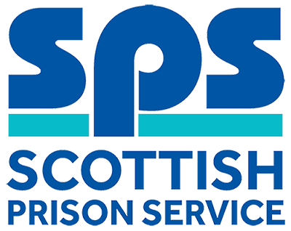

Maintenance Engineer (Mechanical)
Assessment Information

Thank you for your interest in the above role. Below, you will find information on how the different competencies outlined in the person specification will be assessed throughout the Recruitment process as well as information on the vacancy timeline. Throughout the process, you will be assessed against the competencies captured in the person specification and the key behaviours set out in the SPS Behavioural Competency Framework (BCF). All Recruitment at SPS is based on the Behavioural Competency Framework which outlines the key behaviours and standards required both of applicants and existing staff. Further details on the SPS Behavioural Competency Framework can be found on the Careers section of our website.
Please note that applications for this vacancy are by CV. Please click on the apply button to access the online application form and to upload your CV. Our shortlisting process will focus on the essential qualification and experience requirements as outlined in the person specification and we would therefore encourage you to ensure that all qualifications and experiential elements as outlined in the person specification are fully evidenced within your CV.

Competencies you will be assessed against:
Person Specification | Essential  /Desirable | Assessment
Qualifications
Have completed a recognised apprenticeship in Engineering Services (mechanical) or plumbing or heating and ventilation.  For example SVQ level 2 and a National Certificate (or equivalents), such as City and Guilds.  Please evidence within your CV | Essential | CV
Hold a current relevant mechanical qualification to match the above. Ideally have a commercial heating and/or catering gas qualification and be Gas Safe registered.  Please evidence within your CV (where applicable) | Desirable | Interview
Experience
Have experience of mechanical services, plumbing and heating maintenance on industrial/ commercial systems. Also experience of mechanical maintenance and repairs including fire systems and equipment.  Please evidence within your CV | Essential | CV  Interview
Be multi skilled and have experience of other Estates maintenance and repair tasks such as electrical and building works maintenance and repairs or be willing to develop these skills.  Please evidence within your CV | Essential | CV  Interview
Full driving licence that enables the person to drive in the UK, however SPS is willing to consider proposals put forward by applicants to carry out the duties by any other means. | Essential | Interview
Knowledge & Skills
Sound knowledge of Health and Safety Legislation, Safe Systems of Work and contingency planning. | Essential | Interview
Ability to interpret from drawings, instructions and specifications. | Essential | Interview
Basic working knowledge of IT systems and packages that include Outlook and Internet Explorer. | Essential | Interview
Self-motivated with the ability to make decisions and resolve problems within clearly defined parameters. | Essential | Interview

Selection Process Timeline:
Application Window | Live: 8 June 2018  Close: 29 June 2018
Short-listing | 03 July 2018  We will review of your application to determine who is being shortlisted for the assessment day. We will update you of the outcome via the Online Recruitment system.
Assessment Day | 18 July 2018  This assessment day will consist of an Interview. Further information will be provided to candidates progressing to this stage of the process by way of a formal invite to assessment.

