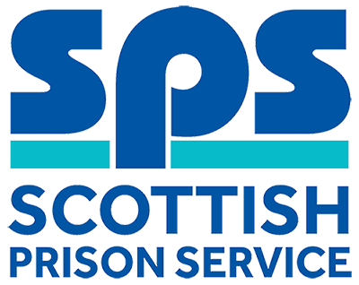

Maintenance Operative
Assessment Information

Thank you for your interest in the above role. Below, you will find information on how the different competencies outlined in the person specification will be assessed throughout the Recruitment process as well as information on the vacancy timeline.
Our shortlisting process will focus on the essential qualification and experience requirements as outlined in the person specification and we would therefore encourage you to ensure that all qualifications and experiential elements as outlined in the person specification are fully evidenced within your application.

Competencies you will be assessed against:
Person Specification | Essential  /Desirable | Assessment
Qualifications
Minimum of two National 5's, including Maths and English or equivalent qualifications or relevant experience of practical or manual working. | Essential | Application
Experience
Skills and experience in using and handling tools and equipment; please provide examples of your experience. | Essential | Application  Interview
Full Driving Licence that enables the person to drive in the UK, however SPS is willing to consider proposals put forward by applicants to carry out the duties by any other means. | Essential | Interview
Experience in carrying out basic engineering maintenance, repair tasks, grounds maintenance and painting; please provide examples of your experience. | Desirable | Interview
Knowledge & Skills
A basic understanding of Health and Safety in the workplace; please provide examples. | Essential | Interview
Be able to work as part of a team; please provide examples. | Essential | Interview
Positive attitude towards training and learning new skills; please provide examples. | Essential | Interview
Have a flexible approach to a wide variety of tasks; please provide examples. | Essential | Interview

Selection Process Timeline:
Application Window | Live: 18 February 2019  Close: 8 March
Short-listing | 11 March  We will review your application to determine who is being shortlisted for the assessment day. We will update you of the outcome via the Online Recruitment system.
Assessment Day | 19 March  This assessment day will consist of an Interview. Further information will be provided to candidates progressing to this stage of the process by way of a formal invite to assessment.

