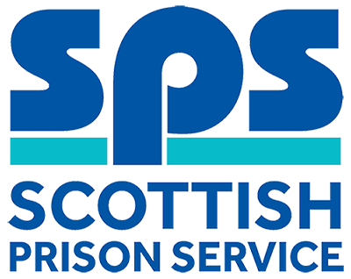

Intelligence Unit Admin Assistant
Assessment Information

Thank you for your interest in the above role. Below, you will find information on how the different competencies outlined in the person specification will be assessed throughout the Recruitment process as well as information on the vacancy timeline. Throughout the process, you will be assessed against the competencies captured in the person specification and the key behaviours set out in the SPS Behavioural Competency Framework (BCF). All Recruitment at SPS is based on the Behavioural Competency Framework which outlines the key behaviours and standards required both of applicants and existing staff. Further details on the SPS Behavioural Competency Framework can be found on the Careers section of our website.

Competencies you will be assessed against:
Person Specification | Essential  /Desirable | Assessment
Qualifications
A minimum of 3 Standard Grades or equivalent including English and Maths / Arithmetic at Grade 3 or Above or relevant experience | Essential | Sift 1
Experience
Experience in carrying out administrative duties within a busy office environment | Essential | Competency Sift  Interview
Competent and experienced in the use of Microsoft Packages | Essential | Competency Sift  Interview
Experience of working with confidential or restricted information | Desirable | Interview
Knowledge & Skills
Well-developed communication skills, both written and oral | Essential | Interview
Ability to work with minimum supervision and prioritise workload | Essential | Interview
Knowledge of relevant national legislation and guidelines | Desirable | Not assessed
Awareness of relevant SPS Security Policies and Procedures | Desirable | Not assessed

Selection Process Timeline:
Application Window | Applications close Wednesday 21st November 2018
Competency Sift | Week commencing 26th November 2018
Competency Interview | Week commencing 10th December 2018

