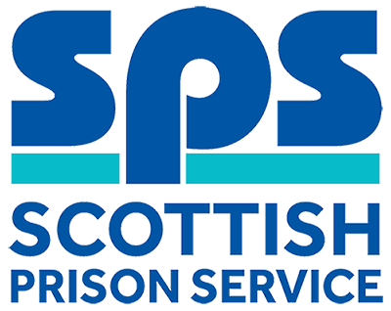
HR Manager (Policy & Reward)
Assessment Information

Thank you for your interest in the above role. Below, you will find information on how the different competencies outlined in the person specification will be assessed throughout the Recruitment process as well as information on the vacancy timeline. Throughout the process, you will be assessed against the competencies captured in the person specification and the key behaviours set out in the SPS Behavioural Competency Framework (BCF). All Recruitment at SPS is based on the Behavioural Competency Framework which outlines the key behaviours and standards required both of applicants and existing staff. Further details on the SPS Behavioural Competency Framework can be found on the Careers section of our website.

Competencies you will be assessed against:
Intrinsic Characteristics | Assessment Methods
Cognitive Ability | Cognitive Ability Test – verbal & numerical reasoning.

Person Specification | Essential  /Desirable | Assessment
Qualifications
Chartered Member of the Chartered Institute of Personnel & Development (CIPD) or actively working towards and likely to achieve within a 6 month period. | Essential | Application  Interview
Degree-level qualification in an HR or business related discipline. | Desirable | Interview
Experience
Experience in the design, development, implementation and review of HR products such as policies, procedures or collective agreements. | Essential | Application  Written Exercise  Interview
Experience of interpreting and applying key aspects of employment law, taking account of organisational context. | Essential | Application  Interview
Experience in the management of Employee Reward or Employee Relations. | Essential | Application  Interview
Knowledge & Skills
Communication & Interpersonal Skills  Excellent interpersonal and communication skills (both verbal and written) with the ability to vary and tailor your style of communication to suit the needs of the audience. | Essential | Written Exercise  Interview
Planning, Implementation and Control  Evidence of your excellent organisational skills, demonstrating your ability to prioritise, forward plan and manage competing demands of your own and others’ workload to ensure outputs are delivered on time. | Essential | Interview
Problem Solving & Decision Making  Excellent decision-making skills with evidence of your ability to analyse complex issues, problem solve and produce credible recommendations by exercising a high level of initiative, judgement and discretion in proposing appropriate actions to be undertaken. | Essential | Written Exercise  Interview
Building & Maintaining Relationships  Leadership and management skills with the ability to build and maintain effective working relationships with all internal and external stakeholders, demonstrating your ability to negotiate with and positively influence others to achieve desired results. | Essential | Interview

Selection Process Timeline:
Application Window | Live: 03 January 2019  Close: 17 January 2019
Cognitive Ability Testing | Please note: all candidates who submit an application will be invited to complete psychometric testing. Your test results will be considered alongside your application form to determine whether you will be progressed to the next stage of the selection process.  Live: 18 January 2019  Close: 25 January 2019  You will be emailed by our testing providers to your nominated email address, with links to the testing; these links will be open for 24 hours a day during the above dates.  Failure to complete will result in your application being withdrawn
Shortlisting  Outcomes of Cognitive Ability Testing and Application Review | 29 January 2019  Your cognitive ability test results will be considered alongside your application form performance to determine whether you will be progressed to the next stage of the selection process.  We will update you of the outcome via the Online Recruitment system. If successful you will attend a Written Exercise.
Written Exercises | 01 February 2019  Candidates successful at shortlisting will be invited to attend a Written Exercise to determine whether you will be progressed to the next stage of the selection process  We will update you of the outcome via the Online Recruitment system.  Candidates successful at Written Exercise will attend Interview
Assessment Day(s) | The Assessment Day will consist of an Interview, taking place on  - 14 February 2019  Further information will be provided to candidates progressing to this stage of the process by way of a formal invite to assessment.

