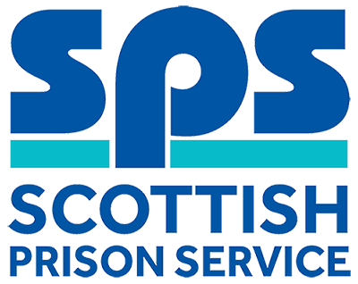

Deputy Area Maintenance Manager
Assessment Information

Thank you for your interest in the above role. Below, you will find information on how the different competencies outlined in the person specification will be assessed throughout the Recruitment process as well as information on the vacancy timeline. Throughout the process, you will be assessed against the competencies captured in the person specification and the key behaviours set out in the SPS Behavioural Competency Framework (BCF). All Recruitment at SPS is based on the Behavioural Competency Framework which outlines the key behaviours and standards required both of applicants and existing staff. Further details on the SPS Behavioural Competency Framework can be found on the Careers section of our website.

Competencies you will be assessed against:
Person Specification | Essential  /Desirable | Assessment
Qualifications
Degree in Facilities Management or related discipline or significant facilities management experience. | Essential | Application
NEBOSH National General Certificate Course in Occupational Health and Safety. | Desirable | Application
Experience
Facilities Management  Facilities or Estate management experience with responsibility for planning, co-ordinating, implementing and monitoring maintenance services and contracts. | Essential | Application  Presentation  Interview
People Management  Experience of leading, directing, influencing and empowering people and teams to deliver organisational outcomes. | Essential | Application  Interview
Project Management  Experience of successfully delivering projects through the effective application of project management skills and techniques. | Desirable | Application  Interview
Knowledge & Skills
Planning, Implementation and Control  Evidence of your excellent organisational skills, demonstrating your ability to prioritise, forward plan, manage competing demands, and work under pressure to ensure outputs are delivered within organisational timescales and budget. | Essential | Presentation  Interview
Problem Solving & Decision Making  Evidence of your ability to assess complex and dynamic situations and issues and exercise effective decision making to implement appropriate solutions. | Essential | Presentation  Interview
Building and Maintaining Relationships  Excellent interpersonal skills with evidence of working effectively, flexibly and collaboratively with internal and external stakeholders, demonstrating your ability to negotiate with and positively influence others to achieve desired results. | Essential | Interview
Legislation  Working knowledge of current Health and Safety legislation and other relevant statutory legislative requirements. | Essential | Presentation  Interview

Selection Process Timeline:
Application Window | Live: 07 January 2018  Close: 21January 2018
Short-listing | 22 January 2019  You will be notified of the outcome of the shortlisting process via the online recruitment system.
Behaviour Profiling Questionnaire | Live: 25 January 2019  Close: 01 February 2019  If shortlisted for assessment you will be asked to complete an online behavioural profiling questionnaire. This allows us to gather information on your motives, talents and preferences in the workplace and the information collected will inform the interview process.  If progressing to the assessment day, you will be emailed by our testing providers to your nominated email address, with links to the Behaviour Profiling questionnaire which will feed into the interview process; these links will be open for 24 hours a day during the above dates.
Assessment Day(s) | 19 February 2019  This assessment day will consist of a Presentation and Interview. Further information will be provided to candidates progressing to this stage of the process by way of a formal invite to assessment.

