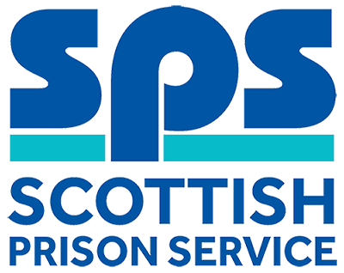

Technical Manager (Mechanical)
Assessment Information

Thank you for your interest in the above role. Below, you will find information on how the different competencies outlined in the person specification will be assessed throughout the Recruitment process as well as information on the vacancy timeline. Throughout the process, you will be assessed against the competencies captured in the person specification and the key behaviours set out in the SPS Behavioural Competency Framework (BCF). All Recruitment at SPS is based on the Behavioural Competency Framework which outlines the key behaviours and standards required both of applicants and existing staff. Further details on the SPS Behavioural Competency Framework can be found on the Careers section of our website.

Competencies you will be assessed against:
Person Specification | Essential  /Desirable | Assessment
Qualifications
Have completed a recognised apprenticeship in in Engineering Services (mechanical) or plumbing or heating and ventilation.  For example SVQ level 3 or City and Guilds Level 3 and a National Certificate (or equivalent) in Engineering Services (mechanical) or plumbing or heating and ventilation.  You will hold a current gas qualification. | ESSENTIAL | Application
Have completed HNC in an engineering subject or prepared to work towards one with full support from SPS if required. | ESSENTIAL | Interview
Experience
ESTATES MAINTENANCE EXPERIENCE  Experience of mechanical, gas, plumbing, heating and ventilation maintenance and repair work and also a willingness to develop new skills in electrical and building maintenance. This includes experience of providing support, advice and direction to others in carrying out installation works or complex mechanical repairs. | ESSENTIAL | Application  Interview
IT SKILLS  Proven IT skills within a maintenance environment. | ESSENTIAL | Interview
DRIVING/TRAVEL  A full driving licence that enables the person to drive in the UK, however SPS is willing to consider proposals put forward by applicants to carry out the duties by any other means. | ESSENTIAL | Interview
Knowledge & Skills
KNOWLEDGE OF LEGISLATION  Sound knowledge of relevant legislation including Health & Safety, Safe Systems of Work, Building and Fire Regulations, Lifting Operations and Lifting Equipment regulations (LOLER) and gas regulations. | ESSENTIAL | Application  Discussion Topic  Interview
PLANNING AND PRIORITISING  Evidence of your excellent organisational skills, demonstrating your ability to prioritise, forward plan and manager competing demands to ensure outputs are delivered on time. | ESSENTIAL | Interview
BUILDING AND MAINTAINING RELATIONSHIPS  Evidence of your ability to foster effective working relationships with a range of stakeholders and influence others to achieve desired outcomes. | ESSENTIAL | Discussion Topic  Interview
PROBLEM SOLVING AND DECISION MAKING  Evidence of your excellent problem solving skills and your ability to provide practical and creative solutions to a range of resourcing issues. | ESSENTIAL | Discussion Topic  Interview

Selection Process Timeline:
Application Window | Live: 12 March 2019  Close: 31 March
Short Listing | 9 April  If unsuccessful at this stage you will be notified via the Online Recruitment system.
Assessment Day | The Assessment Day will consist of a Discussion Topic and Interview.  The Assessment Day will take place on 2 May.  Further information will be provided to candidates progressing to this stage of the process by way of a formal invite to assessment.

