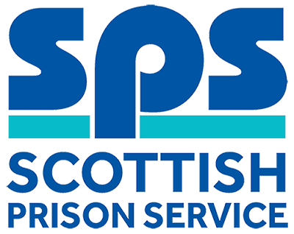

Electrical Maintenance Engineer (Electrician)
Assessment Information

Thank you for your interest in the above role. Below, you will find information on how the different competencies outlined in the person specification will be assessed throughout the Recruitment process as well as information on the vacancy timeline. Throughout the process, you will be assessed against the competencies captured in the person specification and the key behaviours set out in the SPS Behavioural Competency Framework (BCF). All Recruitment at SPS is based on the Behavioural Competency Framework which outlines the key behaviours and standards required both of applicants and existing staff. Further details on the SPS Behavioural Competency Framework can be found on the Careers section of our website.
Please note that applications for this vacancy are by CV. Please click on the apply button to access the online application form and to upload your CV. Our shortlisting process will focus on the essential qualification and experience requirements as outlined in the person specification and we would therefore encourage you to ensure that all qualifications and experiential elements as outlined in the person specification are fully evidenced within your CV.

Competencies you will be assessed against:
Person Specification | Essential  /Desirable | Assessment
Qualifications
Have completed a recognised apprenticeship in an electrical/electronic discipline.  (To include a minimum of an SVQ level 2 and a National Certificate or equivalents, such as City and Guilds). Please evidence within your CV. | Essential | CV/Application
Hold a current electrical qualification in electrical installations, for example BS 7671 or City & Guilds 2382  Training will be provided in 18th Edition Regulations however applicants must be willing to work towards and successfully achieve.  Please evidence within your CV | Essential | CV/Application
Experience
Have experience in inspection and testing on electrical systems and installations in an industrial/commercial environment.  Please evidence within your CV | Essential | CV/Application  Interview
Be multi skilled and have experience of other Estates maintenance and repair tasks such as mechanical and building works maintenance and repairs or be willing to develop these skills. | Essential | Interview
Full driving licence that enables the person to drive in the UK, however SPS is willing to consider proposals put forward by applicants to carry out the duties by any other means. | Essential | Interview
Knowledge & Skills
Sound knowledge of Health and Safety Legislation, Safe Systems of Work and contingency planning. | Essential | Interview
Ability to interpret and work from drawings, instructions and specifications. | Essential | Interview
Basic working knowledge of IT systems and packages that include Outlook and Internet Explorer. | Essential | Interview
Self-motivated with the ability to make decisions and resolve problems within clearly defined parameters. | Essential | Interview
Selection Process Key Dates
Vacancy Closes for Applications | 14 June 2019 | Time | 12 noon
Interview Date* | Due to vacancies being in various locations, these are anticipated to be late June/Early July.
*please note interview dates are subject to change and all dates may not be available.

If you have any queries regarding the vacancy or have a disability which you feel may affect your performance at any stage in the recruitment and selection process, please contact Laura O’Mackie by email at: Laura.O’Mackie@sps.pnn.gov.uk or by telephone on: 01324 710 475 to allow reasonable adjustments to be made to assist you.

