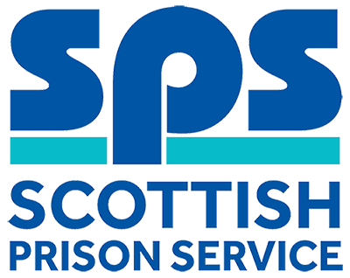

Maintenance Manager
Assessment Information

Thank you for your interest in the above role. Below, you will find information on how the different competencies outlined in the person specification will be assessed throughout the Recruitment process as well as information on the vacancy timeline. Throughout the process, you will be assessed against the competencies captured in the person specification and the key behaviours set out in the SPS Behavioural Competency Framework (BCF). All Recruitment at SPS is based on the Behavioural Competency Framework which outlines the key behaviours and standards required both of applicants and existing staff. Further details on the SPS Behavioural Competency Framework can be found on the Careers section of our website.

Competencies you will be assessed against:
Person Specification | Essential  /Desirable | Assessment
Qualifications
Have completed a recognised apprenticeship in either a mechanical, electrical/electronic, building services discipline.  For Example SVQ level 3 or City and Guilds level 3 and a National Certificate (or equivalent) in either a mechanical, electrical/electronic or building services discipline. | Essential | Application
Have completed an HNC in a relevant engineering subject and an IOSH managing safely certificate or equivalent or prepared to work towards one with full support from SPS. | Essential | Application  Interview
Experience
ESTATES MAINTENANCE EXPERIENCE  Proven experience of facilities management including planned preventative maintenance (PPM) and extensive use Computerised Maintenance Management Systems for delivery of PPM and reactive repairs to ensure compliance and standards are maintained. | Essential | Application  Presentation  Interview
MANAGING AND LEADING  Evidence of providing effective support, direction and motivation to teams whilst setting priorities and objectives. | Essential | Interview
BUDGET  Evidence of your ability to plan, monitor and manage budgets. | Essential | Interview
Knowledge & Skills
KNOWLEDGE AND LEGISLATION  Sound knowledge of relevant legislation, including Health and Safety, Approved Codes of Practice and British Standards. | Essential | Interview
BUILDING AND MAINTAINING RELATIONSHIPS  Evidence of your ability to foster effective working relationships with a range of stakeholders and influence others to achieve desired outcomes. | Essential | Interview
PROBLEM SOLVING AND DECISION MAKING  Evidence of your excellent problem solving skills, your ability to provide practical and creative solutions to a range of issues and empower teams to make appropriate decisions. | Essential | Interview
PLANNING, IMPLEMENTATATION AND CONTROL  Evidence of your excellent organisational skills, demonstrating your ability to prioritise, forward plan and manage competing demands while monitoring team workload and reorganising resources to ensure outputs are delivered on time. | Essential | Interview

Selection Process Timeline:
Application Window | Live: 18 January 2019  Close: 01 February 2019
Short-listing | 04 February 2019  We will review your application to determine who is being shortlisted for the assessment day. We will update you of the outcome via the Online Recruitment system.
Assessment: Presentation & Interview | The final step in the assessment process is a presentation and interview which will take place on the following date:  - 19 February 2019

